22.41: a)(i) 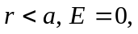 since charge enclosed is zero.
(ii) 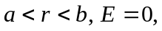 since charge enclosed is zero.
(iii) 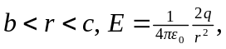 since charge enclosed is 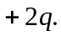
(iv) 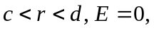 since charge enclosed is zero.
(v) 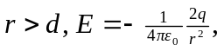 since charge enclosed is 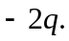

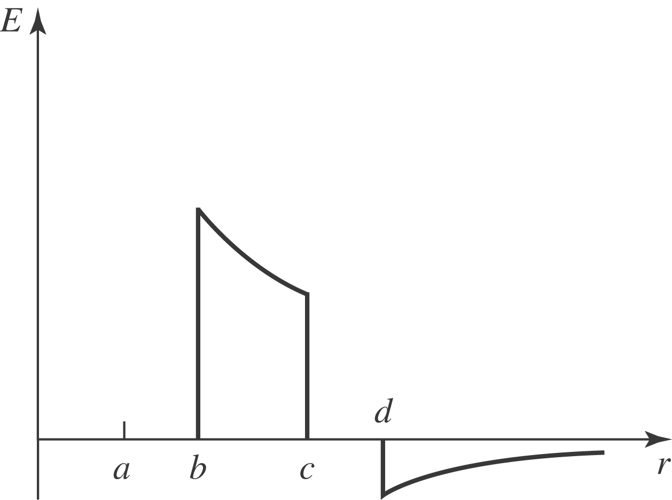

b)(i) small shell inner: 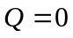
(ii) small shell outer: 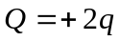
(iii) large shell inner: 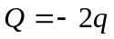
(iv) large shell outer:

